Girl Guides of Canada
Thompson Nicola Area Awards Committee
Quick Reference of Youth Program Awards

Sparks

Fun and Friendship Pin

This is given to a Spark at an advancement ceremony to indicate that they have completed their time in Sparks.

Printable versions of the Spark Advancement Certificate are available at: https://experience.girlguides.ca/node/1312011

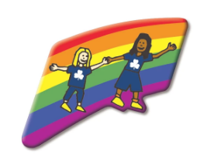

Embers

Fun & Adventure Key Pin

Given at advancement ceremony to indicate that the Ember has completed their time in Embers.

Printable versions of the Embers Advancement Certificate are available at: https://experience.girlguides.ca/node/1312011



Guides

Guide Challenge Pin

Given at advancement ceremony to indicate that the youth has completed their time in Guides. The youth does not need to have completed any part of the program or to have spent three years as Guides to be presented with this pin.

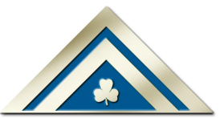

Lady Baden-Powell Challenge

Presented by the Unit Guider when the Guide has completed the challenge requirement. This is the highest award in the Guide Program.

The Lady Baden-Powell Challenge certificates are usually presented by Thompson Nicola Area at an Area/District/Unit Recognition Ceremony.

To track this award completion in iMIS, the Thompson Nicola Area Awards Liaison will fill out the Branch Program Awards form.

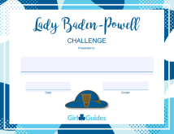

Pathfinders

Building Belonging Certificate

Canadian communities are made up of diverse cultures and unique individuals. Earning the Building Belonging Certificate (formerly known as the Citizenship Certificate) means that the youth understand why it is important for Canada to be a place where everyone can feel like they belong. It also means that the youth took the time to explore the greatness of Canadian communities and people in them. To earn this certificate, the youth must complete either 2-4 activities from each theme or 6-10 activities in total. This can be found in the Girls First Program.

Once the youth has completed the requirements, printable version of the certificate are available at: https://experience.girlguides.ca/node/1312011

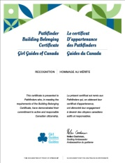

Community Service Award

This is presented to a Pathfinder by their Unit Guider upon completions of community serve projects. This is one requirement for earning the Canada Cord.

Once the youth has completed the requirements, printable version of the certificate are available at: https://experience.girlguides.ca/node/1312011
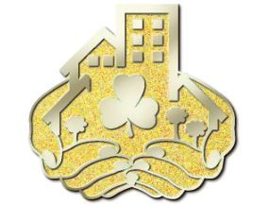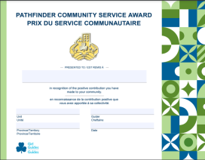

Canada Cord

Refer to program for requirements. The Canada Cord is the highest award that a Pathfinder can earn.

The Canada Cord certificates are usually presented by Thompson Nicola Area at an Area/District/Unit Recognition Ceremony.

To track this award completion in iMIS, the Thompson Nicola Area Awards Liaison will fill out the Branch Program Awards form.

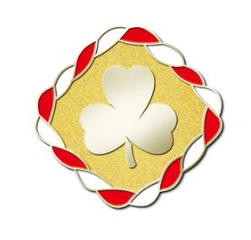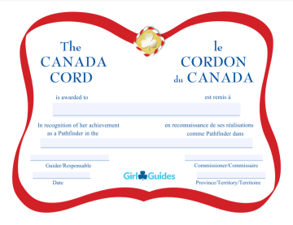

Upon receiving their certificate, they may present it to their school counsellor to obtain 4 (four) school credits.

Rangers

Ranger Certificate of Appreciation

This certificate may be given annually to recognize service as a Ranger.

Printable version of the certificate are available at: https://experience.girlguides.ca/node/1312011

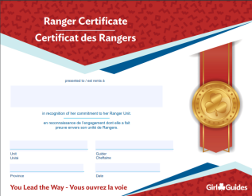

Ranger Service Project Pin & Certificate

Complete one major service project of at least 20 hours including planning. Pin and certificate awarded by the Unit Guider.

Printable version of the certificate are available at: https://experience.girlguides.ca/node/1312011

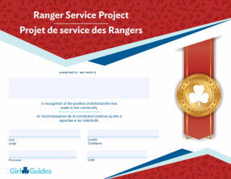

Cookie Challenge Pin & Certificate

Actively participate in four cookie campaigns as a Ranger. Pin and certificate awarded by the Unit Guider.

Printable version of the certificate are available at: https://experience.girlguides.ca/node/1312011

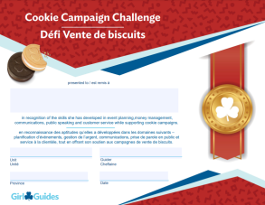

Trailblazer Leadership Bronze Award

Refer to program for requirements. Pin and certificate awarded by the Unit Guider.

Printable version of the certificate are available at: https://experience.girlguides.ca/node/1312011

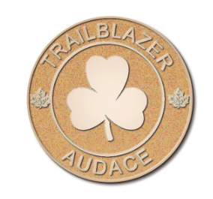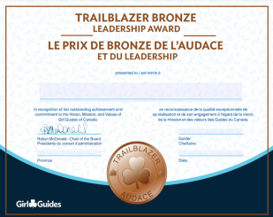

Trailblazer Leadership Silver Award

Refer to program for requirements. Pin and certificate awarded by the Unit Guider.

Printable versions of the certificate are available at: https://experience.girlguides.ca/node/1312011

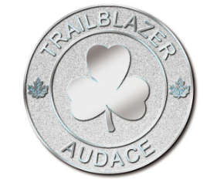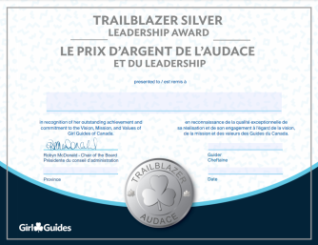

Trailblazer Leadership Gold Award

Awarded on completion of the Bronze and Silver Awards, the Ranger Service Project and the Cookie Campaign Challenge. This award (pin and ribbon) is presented by the Unit Guider in the youth’s third year.

The certificate is usually presented by Thompson Nicola Area at an Area/District/Unit Recognition Ceremony.

Congratulations Letter request form is requested from National by the Thompson Nicola Area Awards Committee and letters will be presented at an Area/District/Unit award ceremony.

To track this award completion in iMIS, the Thompson Nicola Area Awards Liaison will fill out the Branch Program Awards form.

Upon receiving their certificate, they may present it to their school counsellor to obtain 4 (four) school credits.
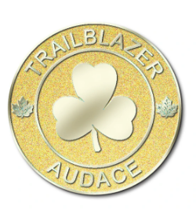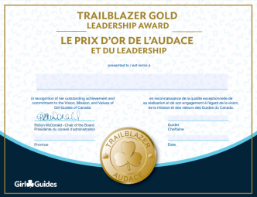

Commonwealth Award

Youths registered in Rangers are eligible to earn this award. It can be found here https://www.girlguiding.org.uk/what-we-do/our-badges-and-activities/badge-finder/commonwealth-award/

Pin and certificate awarded by the Unit Guider. Printable versions of the certificate are available on the Girl First Program under Navigation/Certificates and Awards/Rangers.

This certificate can be presented by Thompson Nicola Area at an Area/District/Unit Recognition Ceremony. You should check the process with your Area Awards Liaison for further clarification of your area’s process.

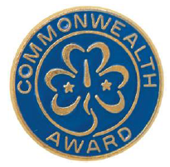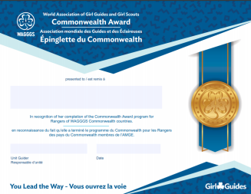

BC Girl Guides – Youth Commitment Pin

The Youth Commitment Award is presented to third-year Rangers who have been a member in all branches from Sparks through to Rangers in recognition and celebration of their long-term commitment to Guiding. To qualify members must have:
- one or two years of Sparks
- two years of Embers
- three years of Guides
- three years of Pathfinders
- three years of Rangers

The list of Rangers eligible for the Youth Commitment Award will be generated from the iMIS records. Certificates are sent automatically in the Spring to the Ranger Contact Guider for presentation to all eligible members.
No application is necessary.

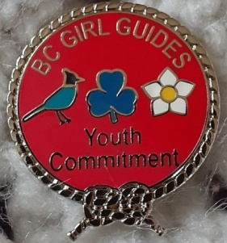

Guides, Pathfinders and Rangers

Junior Leader Certificate of Appreciation

A Junior Leader is committed to working with a unit in a branch of Guiding where the youth are at least two years younger than they are (i.e. Guides can support a Sparks unit). A youth can choose to be a Junior Leader while they work on the Guide/Pathfinder/Ranger program or they can focus on the Junior Leader role. They can rejoin the Guide/Pathfinder/Ranger program anytime.

Each unit will have to register their Junior Leaders each year.
Please contact info@girlguides.ca to have the youth registered in your unit as a Junior Leader.

Printable versions of the certificate are available at: https://experience.girlguides.ca/node/1312011 You can go into any branch and find this certificate.

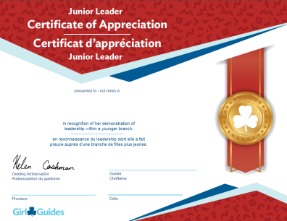

If you have any questions, please contact:

Donna Samson
Thompson Nicola Area Awards Liaison
tnaaward@gmail.com
250-320-7582

