Thompson Nicola Area
Lead the CHEER Challenge
Introduction
Province-wide, all of Guiding has been asked to have our members interact more with the public in our local communities. We know that many units already participate in a variety of outings and service projects that not only benefit our communities but also raise the profile of Girl Guides. Our goal with this challenge is to increase the connection we have within our community.
There are 5 sections in our challenge. Please remember that the activities set out in each section are just suggestions. Feel free to substitute activities so long as the activities you choose are age appropriate and sufficiently challenging for the level of girls involved to meet the spirit of the objective.
Remember to take photos when participating in this challenge, and ALWAYS wear your uniform!

Requirements for Completion
To earn the challenge crest:
Sparks & Brownies: must complete 2 separate activities or events from each section.
Guides & Pathfinders: must complete 3 separate activities or events from each section.
Rangers & Adults: must complete 5 separate activities or events from each section.

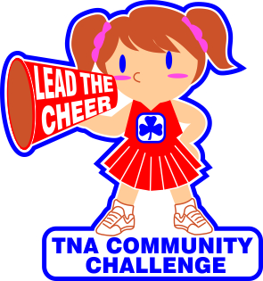
“C”reate Connections 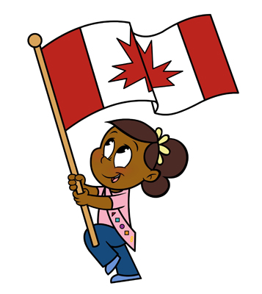
This section is about getting the girls involved in activities related to local government or being seen in the public. Any activities are possible as long as the girls are in uniform and they are out in the community talking to people about Guiding.

  - Staff tables at community and farm markets and promote Guiding to Customers
  - Attend a community event and make contact with organizers and participants
  - Send a letter with pictures to your mayor, MLA, or MP telling them about the value of Guiding in Canada and what Guiding means to girls and women
  - Ask your local municipal councils if Guiding can paint over a “graffiticovered” wall or bench with “Guiding” themed art
  - Visit City/Municipal Councils and have girls talk about their favourite thing in Guiding
  - Organize and participate in a community candlelight walk-about; invite the public to join you for a cup of hot chocolate at the end
  - Ask your local museum, library, school, pre-school, bank, recreation centre, municipal hall or mall if you can set up a display about Guiding
  - Donate a Guiding book to your public library (e.g., Guiding heroes)
  - Help plan, create or decorate a float for a community parade
  - Wear your Girl Guide uniform to school on Thinking Day
  - Wear your Girl Guide uniform to the Remembrance Day Ceremony at your school or in your community
  - Attend a community event as a unit (Art in the Park, Children’s Festival, radio station breakfasts at Christmas)

“H”elping Hands 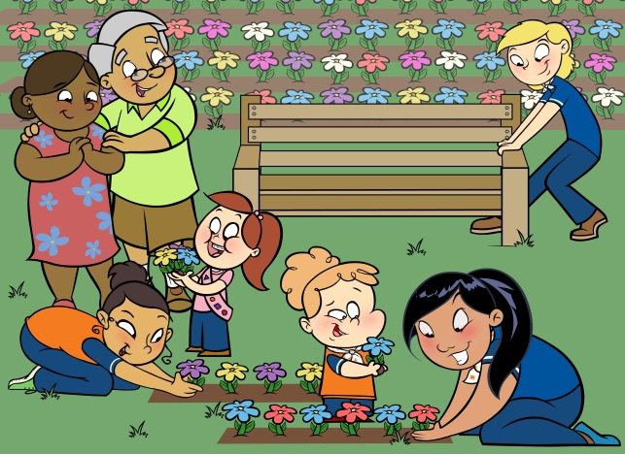

In this section of the challenge, what is important is making a personal connection. If the girls, your councils or your Guild are asked where they would like to make connections or be of service, they will then have a personal interest in making a specific connection that is in keeping with the spirit of the challenge.
- Make cards and give individually to veterans at November 11 events
- Make Valentine cards for veterans or seniors. Have the girls personally present them at a tea or other opportunity to meet and mingle with the recipients
- Participate in Cancer Society daffodil sales or sell poppies to support your local Legion—these two opportunities are within the BC Fundraising Guidelines
- Have each girl bring non-perishable food items that total her age for the local food bank (i.e., an eight year old brings eight items)
- Arrange for the girls to have a tour and help at the local food bank
- Organize a campfire in a seniors’ care facility and sing old and new Guiding songs. You will be amazed how many seniors will remember the words
- Arrange ahead of time to visit with seniors for Grandparents Day
- Wash dishes at a food bank, seniors centre or community hot meal program
- Make a quilt from blocks created by the girls—use embroidery, fabric paints, appliqué etc. and arrange to have the girls present it to a recipient or organization
- Learn to knit or crochet teddy bears—try asking a member of your nearest Trefoil Guild to come and teach the girls to knit
- Volunteer at a local fall fair or craft fair
- Be of service at a community event, volunteer at a local “run”
- Participate in a service project for someone in need (i.e., hygiene kits, socks, mittens, baby hygiene kits)
- Volunteer at the local SPCA to walk dogs or clean kennels
- Help decorate the senior center at Christmas

“E”nvironment 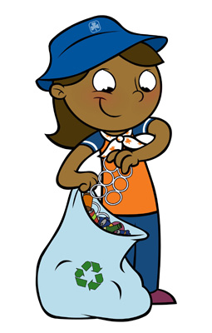

The goal of this section is to connect with our local environment and make a positive change in the community that we all share.

- Plant trees
- Plant different plants at meeting spaces, seniors residents or schools (ask permission first)
- Spray paint storm drains (Yellow fish drain painting)
- Invasive weed pulling
- Help weed at a community garden
- Participate in water awareness program
- Learn about endangered species
- Build bird or bat houses
- Help build or beautify a trail
- Attend a local hatchery
- Participate in “Pitch-in-Canada” or the “Great Canadian Shoreline Clean-up”
- Take a tour of a local water treatment facility

“E”ngage and Educate 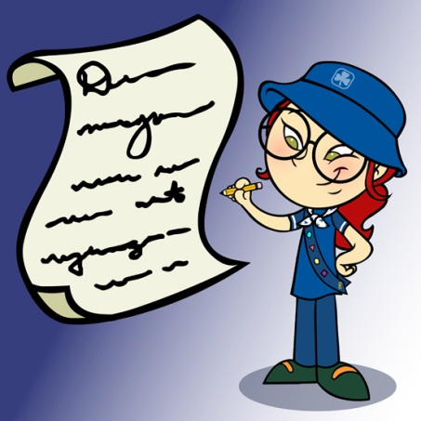
In this section of the challenge, the girls will both educate members of our community about Girl Guides but also learn more about different parts of our community and rolls people play.
- Develop parent/work relationships for Unit visits (e.g., Bring your daughter and her ____Unit to work day! or bring your parents’ co-workers to the Unit meeting?
- Hold a teachers’ appreciation night and have the girls write out personal invitations to their teachers to attend the Unit meeting
- Hold a career night recruiting family, friends and the community
- Invite a resource person or guest speaker to come talk to the girls, your district council or guild about a relevant topic or program item (i.e., the TNRD or City about recycling or water management, Environment Canada, or a UVIC Speakers Bureau presenter)
- Invite a local First Nation’s Band member to come to your Unit meeting and speak about their history
- Have the girls create and distribute a notice about why we collect funds for Canadian World Friendship Fund (CWFF)
- Have a multicultural presentation at your meeting
- Arrange a tour of a multicultural facility or museum in your community
- Invite a Guiding member who has travelled internationally to speak to your Unit
- Have a tea party for your local trefoil Guild
“R”ecreation and Healthy Lifestyles 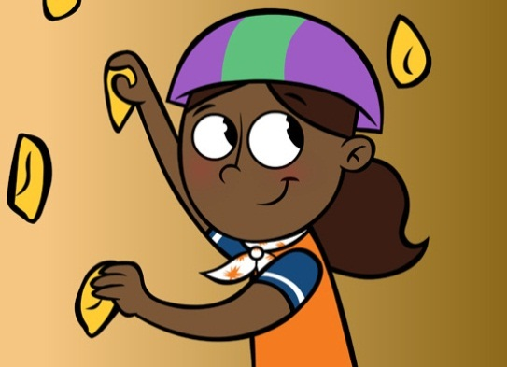
The objective of the challenge is to get Guiding out into the community – this section is about taking a Unit meeting outside the hall. Please choose a location where your Unit has not gone before or doesn’t normally meet.

- Visit a museum, art gallery or public library (maybe the librarian could read to younger girls)
- Tour a grocery store (many hold tours and focus on nutritional snacks and lunches)
- Tour the local fire hall, police station, veterinary clinic, post office, bakery or commercial enterprise of your choosing where tours are offered or can be arranged.
- Tour the water treatment centre
- Tour your local newspaper—maybe you’ll get your picture in the paper.
- Hold a meeting in a public park, at the mall or in the parking lot of your meeting hall/school—anywhere you are outside and can be seen
- Go swimming, curling, skating, or—try something new at your local recreation centre
- Try out a new sport or activity like curling, tennis, yoga, diving, synchronized swimming, dancing, martial arts, lawn bowling or archery at a local club. The possibilities are limitless. For contacts check out your local recreation centre brochure
- Go to an international restaurant and try a food new food
- Be a tourist in your own town
- Visit the Wildlife Park – take in Boo at the Zoo or Wild Lights
- Take a ride on the heritage train
- Travel by public transit to an outing – or complete a scavenger hunt using public transit
- Community scavenger hunt
- Take a walking tour of the heritage sites
- Be a tourist in your own town

To Order Crests
Please contact Tara Decker via email tjd@hmzlaw.com or phone 250-851-8939 to order crests. Each crest is $1.80 which includes all taxes.

